*************HTML CONCEPT**********

* You can simply change text direction, just by using the "dir" attribute in the <bdo> element.

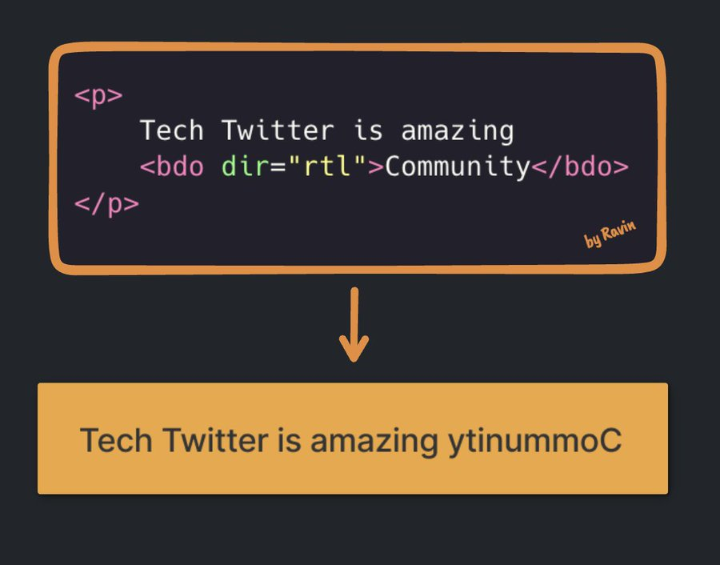

<bdo>: The **Bidirectional Text Override element**

**<rtl> : right to left**

* The <sub> tag **defines subscript text**
* The <**sup**> **tag** defines superscript text.

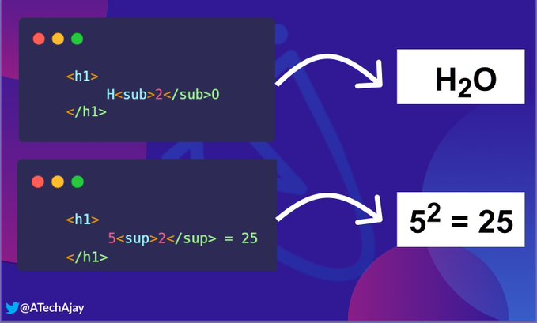

* SEARCH ICON

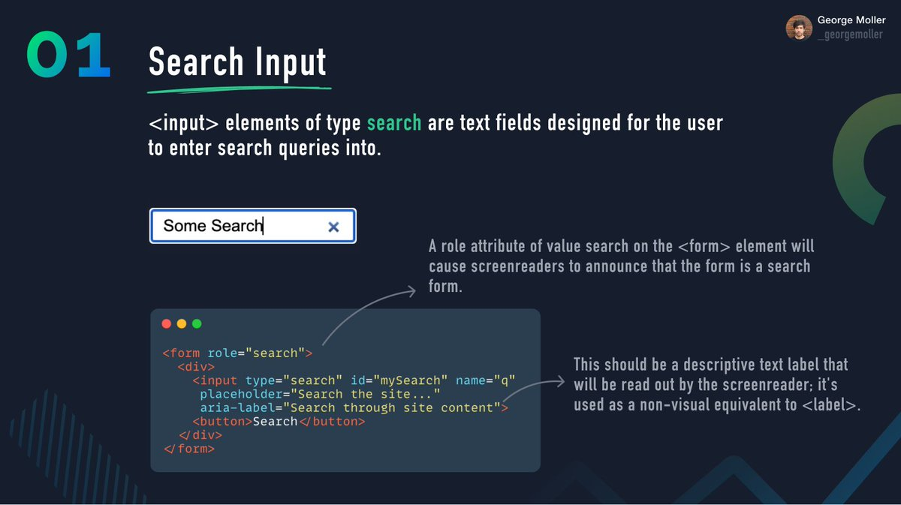

* URL SEARCH





